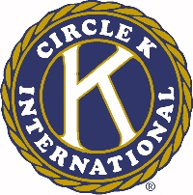
The 46th Annual Ohio District Circle K Convention

David Mathias Outstanding Kiwanis Family Achievement Award

Name of Nominee ________________________________________________________

Circle K club of __________________________________________________________

The recipient of this award will have tried to promote an understanding of and involvement with the different branches of the Kiwanis Family (Builders Club, Circle K, Key Club, and Kiwanis) throughout the current administrative year. Any Circle K club member within the Ohio District, in good standing with Circle K International, excluding currently serving District Board members, is eligible for the award.

The Ohio District Board will base their decision on the following criteria:

- How this individual increased communication between the branches of the Kiwanis Family.

- How this individual increased awareness of the objectives and achievements of the counter branches of the Kiwanis Family.

- Divisional, District, and International Kiwanis Family events this individual attended.

- Any other information that you believe makes this individual outstanding and deserving of this award.

Submission of the above information must be in short answer essay form for each of the four criteria by a Kiwanis member, Kiwanis or Faculty Advisor, or a Circle K member.

